YF-B6 & B10 PRODUCT DETAILS
Water flow sensor consists of a copper body, a water rotor, and a hall-effect sensor. When water flows through the rotor, rotor rolls. Its speed changes with different rate of flow. The hall-effect sensor outputs the corresponding pulse signal. This one is suitable to detect flow in water dispenser or coffee machine.
Life is longer than plastic body.

Features
• Compact, Easy to Install
• High Sealing Performance
• High Quality Hall Effect Sensor
• RoHS Compliant
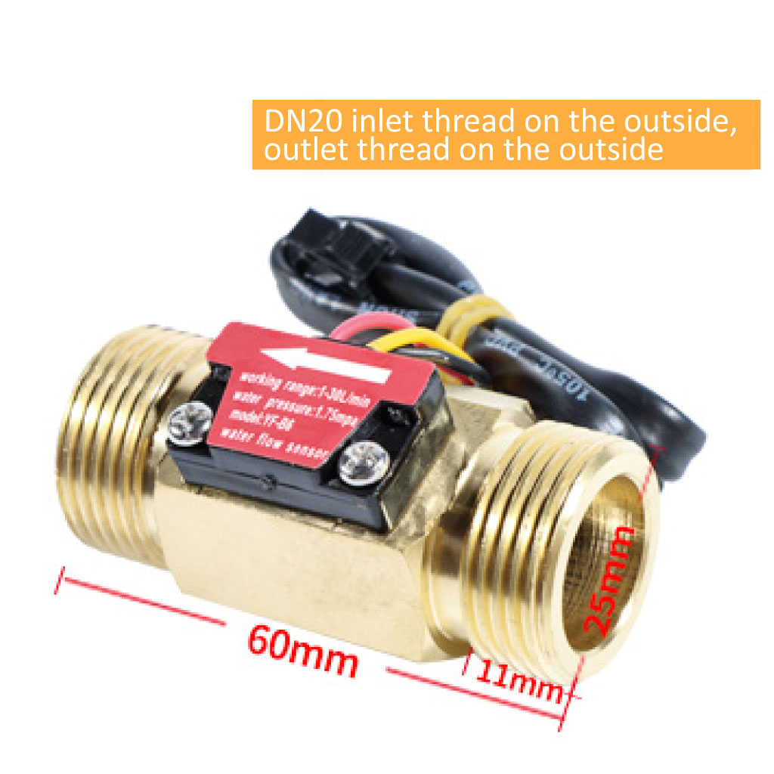

Type | Dimensions | Working Voltage | Flow Rate Range | Length | Male & Female | Length of Thread | Material
YF-B6 | DN20 (3/4”) | 5V~15V(DC) | 1~30L/min | 60mm | Double Male | 11mm | Copper
YF-B10 | DN25 (1”) | 5V~15V(DC) | 1~30L/min | 60mm | Double Male | 11mm | Copper

Technical details
Weight | G.W 152g
Mini. Wokring Voltage | DC 4.5V
Max. Working Current | 15mA (DC 5V)
Working Voltage | DC 5V~15V
Flow Rate Range | 1~30L/min
Frequency | F=(6.6*Q)Q=L/MIN±3%
Load Capacity | ≤10mA (DC 5V)
Operating Temperature | 0 ~ 80℃
Liquid Temperature | ≤120℃
Operating Humidity | 35%～90%RH
Water Pressure | ≤1.75MPa
Storage Temperature | -25～+ 80℃
Storage Humidity | 25%～95%RH
Error Range | (1~25L\MIN) ±3%
Material Description | H57Copper+POM
Output Pulse High Level | >DC 4.7V (Input Voltage DC5V)
Output Pulse Low Level | <DC 0.5V (Input Voltage DC5V)
Output Pulse Duty Cycle | 50%±10%
Wire Connection | – Terminal 1 (Red): VDD +  – Terminal 2 (Black): GND -  – Terminal 3 (Yellow): Signal VOut (GND Referenced/Open Drain , i.e. Requires Pull-Up)

